The first quality of a soldier is constancy in enduring fatigue & hardship.
Courage is only second.
-Napoleon Bonaparte
In 1863 the more than 14,000 men of U.S. General John Sedgwick’s Sixth Corps marched from Virginia to Pennsylvania to reach the Battle of Gettysburg. Their timely arrival changed history.
Our 145th anniversary march will honor their devotion to duty, cause, and comrades as we retrace that route from Fairfax, Virginia to Little Round Top.

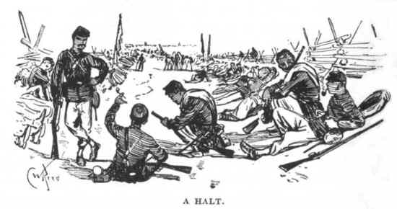

Registration
If you would be interested in participating in this march
(or assisting with logistics),
please contact me in email
doug@dougdobbs.com
or by phone
C: 717-816-2941
Stay up to date via our web pages at www.dougdobbs.com

We can always use support vehicles, water supply, medical & communications staff. If you have a special skill or talent you would like to contribute, please let me know.

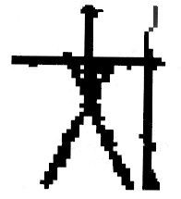

Stickbug Interative
Mercersburg, PA
www.dougdobbs.com/stickbug
Sixth Corps To Gettysburg

June 25 - July 2
1863 – 2008
145th Anniversary March

Some were heroes
on the battlefield.
Some were heroes
just to get there.

Itinerary
Route and timing will primarily follow First Brigade, First Division of the Sixth Corps.

Thursday, June 26th 1:30 AM: Leave Fairfax (VA) Courthouse, to Dranesville, VA. Call for specific route.
Friday, June 27th early: Leave Dranesville, West along Rt. 7 to Goose Creek. Cross the Potomac to Edward’s Ferry, MD.
Saturday, June 28th 5 AM: Leave Edward’s Ferry, to Poolesville, MD route 109 N. through Beallsville, Barnesville and Comus to Hyattstown, MD.
Sunday, June 29th 5AM: Leave Hyattstown, N on MD Rt. 75 through Monrovia, under I-70, and E. on Old National Pike to Ridgeville. N. on Rt. 27 to the vicinity of Taylorsville.
Monday, June 30th, 10:30 AM: Leave Taylorsville N. on MD Route 27 through Warfieldsburg, Westminster, Cranberry and Mexico, and on to the Manchester area.
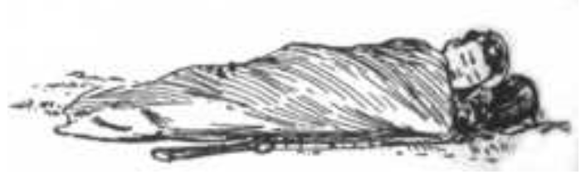Tuesday, July 1st -Wednesday July 2nd: Remain in the Manchester area. Leave 10 PM Tuesday on Md. Route 27 S., back to Westminster. Turn N. on Rt. 97, through Mt. Pleasant, Union Mills, Silver Run, Md. and into Pa., through Littlestown, Germantown, Two Taverns, and on to Little Round Top at the Gettysburg National Military Park.

March to Gettysburg
1863 June 25-July 2 2008

Come join the memorial march to mark the 145th anniversary of the Federal Sixth Corps’ movement to Gettysburg. This event will retrace the steps of Gen. "Uncle John" Sedgwick’s troops from Fairfax, Virginia to Gettysburg, Pennsylvania. Their arrival there was key to the defense of Little Round Top. Our march will follow the route taken by the troops in 1863, as close to the original times and dates as possible.
The goal is to keep at least a color guard moving at the original pace throughout the course of each day's journey. Once registered, you may join us along the way and participate for as long as you choose. There are several ways to participate, see the website for details. We are expecting many opportunities for impromptu living history and education. Further information is available online, at www.dougdobbs.com/cwr. We’re asking $13/day to cover permits, food, water etc.
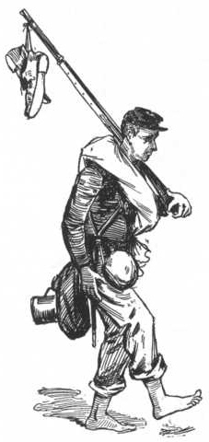
This will be a great opportunity to have a real sense of how the soldiers felt while moving, by day and by night, marching long distances, pushing themselves and supporting their comrades, knowing they were headed for battle. Your feet may be sore, your throat may feel dry, your shoulders may ache, but you will understand better what the soldiers went through before the final push to Little Round Top and the Wheatfield.
If you are a veteran of previous “Stickbug death marches,” please come join us again. If you are new to marching and campaigning, please come learn along with us. We are not requiring a preservation donation this time, but if you wish to raise funds on your own we can suggest some organizations we feel are doing worthy work for battlefield preservation.

